Data Structures & OOP
Final Project Report


Finance Tracker App
Made By:
Shakira Hayau Mazaya Gutomo (2902708363)
Stephanie Rebecca Zeekeon (2902693866)
Nabil Ghani Sjarief (2902604002)

11 June 2026
Table of Contents

CHAPTER 1 4
Project Specifications 4
I. Background 4
II. Problem Description 5
CHAPTER 2 6
Solutions 6
A. Solution 1: ArrayList + HashMap 6
B. Solution 2: TreeSet + TreeMap 6
CHAPTER 3 8
Experimentation & Complexity 8
Runtime Measurement & Comparison Table 8
a. Insertion at the front 8
b. Insertion in the Middle 9
c. Insertion at the End 11
Growth Graph 12
A. Insertion at the Front 12
B. Insertion at the Middle 13
C. Insertion at the End 14
Complexity Analyses 15
CHAPTER 4 16
Conclusion 16
CHAPTER 5 17
Program Screenshots and Class Structure 17
UML Class Diagram 17
Documentation 17
REFERENCES 20
APPENDIX 22
Program Manual 22
Git Repository Link 22
Presentation Link 22

CHAPTER 1

Project Specifications

Background
The twenty-first century is currently undergoing a profound structural shift driven by the “Data revolution” that fundamentally transforms economic analysis professionally and daily life (Einav & Levin, 2014). Historically, detailed economic tracking and financial database recording were restricted to corporate organizations and state institutions. However, with the rapid rise of digital banking and e-money (electronic money) such as SeaBank, GoPay, etc., individuals are able to generate high-frequency streams of personal financial statistics where they can access economic details that are curated to their spending behavior (Kenney & Zysman, 2016). Individuals have increasingly relied on tools within the platform economy to manage their personal finances, meticulously tracking the daily income and expenses (such as Amount, Date, Category) to optimize their spending and savings. In accordance with this, the domain of micro-level economic behavior has become a critical area for structural analytical study. Optimizing individual savings, investment capacity, and budgetary health relies on the individual’s ability to monitor these statistics via a reliable tracking tool (Jarmin, 2019).
To effectively monitor these financial patterns, a complex but neat personal finance system must be able to deliver several critical metrics for every single transaction. First, the application needs to record temporal metrics, which provide precise timestamps (date, month, and year) representing when the economic transaction occurred. Second, the application must log quantitative metrics that reflect the exact monetary value and corresponding currency exchange parameters of the transaction. Lastly, the system must have categorical metrics, which serve as essential classification markers like food, utilities, transport, etc., necessary for conducting comprehensive structural budget analysis. These are the three main features that we will be covering in our daily expense tracker application.
As users track their expenses over multiple months and years,the micro-data entries naturally accumulate into a huge chunk of historical datasets, mimicking the behavior of institutional big data. This continuously expanding volume demands that contemporary financial information systems re-evaluate how they process tracking statistics. Personal finance applications can no longer treat their storage systems as simple, static lists. Instead, they must be engineered as optimized as possible, enabling high-performance information systems that are capable of handling rapid queries, multi-attribute sorting, and continuous data insertion without degrading the user interface experience.

Problem Description

It's common these days to have applications that work as a finance tracker app. However, the dataset grew over the years, especially for people who consistently update their financial expenses. Often, these datasets scale to hundreds of thousands of entries and some applications do not function as they grow. This means, whenever a user is trying to categorise an expense and filter based on date range, it might take minutes for it to load. Because of this, it wastes everyone’s time and makes it difficult for people who don’t have minutes to waste.

CHAPTER 2

Solutions

This project requires a method that can be implemented efficiently and can sort data while also tracking its contents. From this, we have chosen 2 possible solutions which will be compared with the required criteria for the best possible outcome.

Solution 1: ArrayList + HashMap
An arraylist is a data structure that takes the form of a resizable array, which means its size grows dynamically as elements are added. It allows fast access to

The way this method would work would be as follows:
- Mechanism: Uses an ArrayList to store the chronological ledger of expenses and a HashMap to store running totals by category.
- Insertion Time Complexity: O(1). Adding new expenses is instantaneous.
- Search/Aggregation by Category: O(1).
- Search by Date Range: O(n). Finding a monthly summary requires a linear scan of every item in the ArrayList, which will cause lag for users with years of data.

Despite being theoretically a simpler method, it may be performance heavy when the data is in large numbers.

Solution 2: TreeSet + TreeMap
A Treeset is a collection of data that takes the form of a self balancing tree. This means that the tree keeps its height balance after insertion and deletion which allows a program using it to run fast with predictable performance.
The way this method would work in the context of this program would be as follows:
- Mechanism: Uses a TreeSet (ordered by date using a custom comparator) to store the ledger and a TreeMap for categories.
- Insertion Time Complexity: O(log n). Slower than Implementation A, as the system must rebalance the tree upon every entry.
- Search/Aggregation by Category: O(log n).
- Search by Date Range: O(log n).

Theoretically, this method can be more efficient compared to solution 1, because the self balancing tree avoids massive memory shifts.

CHAPTER 3

Experimentation & Complexity

We experimented on which data structure is the most efficient for our program by testing a runtime calculation based on the system nanotime. By running these tests on a varying input size ranging from 1 to 100000, we will be able to determine the speed at which each data structure can run its designated task faster. The differences between the two are shown in the table below:

Runtime Measurement & Comparison Table

Insertion at the front

Operation Type | Data Structure | Input Size | Runtime (Milliseconds)
Insertion at the Front | TreeSet + TreeMap | 1 | 0.0122
Insertion at the Front | ArrayList + HashMap | 1 | 0.0343
Insertion at the Front | TreeSet + TreeMap | 10 | 0.0155
Insertion at the Front | ArrayList + HashMap | 10 | 0.1447
Insertion at the Front | TreeSet + TreeMap | 100 | 0.0287
Insertion at the Front | ArrayList + HashMap | 100 | 0.7063
Insertion at the Front | TreeSet + TreeMap | 1000 | 0.1908
Insertion at the Front | ArrayList + HashMap | 1000 | 6.2237
Insertion at the Front | TreeSet + TreeMap | 10000 | 0.8880
Insertion at the Front | ArrayList + HashMap | 10000 | 109.3032
Insertion at the Front | TreeSet + TreeMap | 100000 | 15.0447
Insertion at the Front | ArrayList + HashMap | 100000 | 8423.2988

Insertion in the Middle

Operation Type | Data Structure | Input Size | Runtime (Milliseconds)
Insertion at the Middle | TreeSet + TreeMap | 1 | 0.0036
Insertion at the Middle | ArrayList + HashMap | 1 | 0.3312
Insertion at the Middle | TreeSet + TreeMap | 10 | 0.0412
Insertion at the Middle | ArrayList + HashMap | 10 | 2.3874
Insertion at the Middle | TreeSet + TreeMap | 100 | 0.0975
Insertion at the Middle | ArrayList + HashMap | 100 | 17.6233
Insertion at the Middle | TreeSet + TreeMap | 1000 | 0.4548
Insertion at the Middle | ArrayList + HashMap | 1000 | 269.0703
Insertion at the Middle | TreeSet + TreeMap | 10000 | 2.4218
Insertion at the Middle | ArrayList + HashMap | 10000 | 887.6407
Insertion at the Middle | TreeSet + TreeMap | 100000 | 10.6011
Insertion at the Middle | ArrayList + HashMap | 100000 | 26838.0886

Insertion at the End

Operation Type | Data Structure | Input Size | Runtime (Milliseconds)
Insertion at the End | TreeSet + TreeMap | 1 | 0.0084
Insertion at the End | ArrayList + HashMap | 1 | 0.8204
Insertion at the End | TreeSet + TreeMap | 10 | 0.0275
Insertion at the End | ArrayList + HashMap | 10 | 5.9005
Insertion at the End | TreeSet + TreeMap | 100 | 0.0364
Insertion at the End | ArrayList + HashMap | 100 | 39.3733
Insertion at the End | TreeSet + TreeMap | 1000 | (0.1232
Insertion at the End | ArrayList + HashMap | 1000 | 218.8090
Insertion at the End | TreeSet + TreeMap | 10000 | 1.7379
Insertion at the End | ArrayList + HashMap | 10000 | 3482.9409
Insertion at the End | TreeSet + TreeMap | 100000 | 9.5152
Insertion at the End | ArrayList + HashMap | 100000 | 44091.4026

Growth Graph

Insertion at the Front
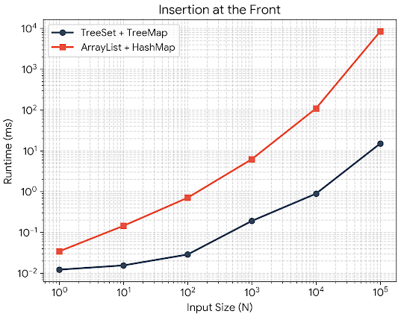
Both the arraylist engine and the tree engine were capable of producing fast results while the input size was small. However, due to the arraylist engine having a complexity of O(N), it requires more time as the input size grows compared to the tree engine which has a complexity of O(log n) which by the time the input size has reached 100000, is massively faster than the arraylist engine which is also due to arraylist having to shift 100000 items to the right to make space.

Insertion at the Middle
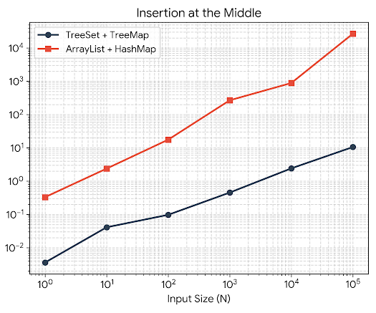
In middle insertion, the difference between the arraylist engine and the tree engine is way more visible on lower input sizes. For the tree engine, finding a position in the middle of the dataset takes roughly the same number of pointer-hopping steps as finding the front or the end. The arraylist engine becomes increasingly slower as it has to scan step-by-step through the array until it reaches the middle point just to find the index then shift the remaining half of the array to make space. All of that resulted in the arraylist taking nearly 27 seconds at 100000 items.

Insertion at the End
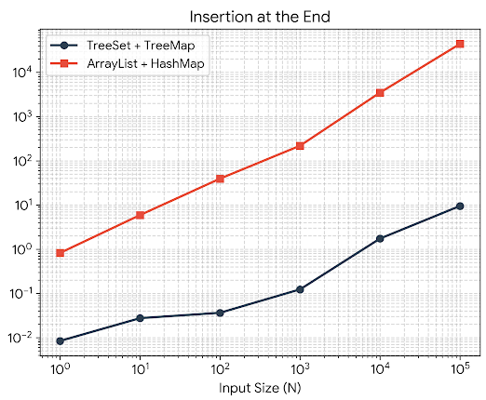
For insertion in the end, the tree engine is still faster. It simply navigates down to the right-most leaf node with the complexity of O(log N) and attaches the new element. The arraylist engine however, is performing even worse than before because it has to loop N-1 an amount of times which results in it having to loop 100000 times to insert the 100000th item.

Complexity Analyses
We were able to find the best possible solution by testing both data structures using a test data size of 100000 and varied input size ranging from 1 to 100000.
The TreeSet uses a self-balancing binary search tree, which maintains organized data hierarchically rather than in a flat sequence. Whenever something is added, whether the data places it logically at the front, middle, or end, the CPU will be able to execute its traversal consistently down the tree branches. This method scales with a O(log N) behavior, meaning that even if the input size is as large as 100000, it takes less than 20 steep comparisons to safely allocate a new memory node and wire its pointer references. Because of this, the execution time of the tree is nearly instant across all tests, clocking in at 9 to 15 milliseconds at most.

Meanwhile, the ArrayList method treats memory as a single, adjacent linear block. When inserting an entry to the front, the computer must sequentially shift every single existing record to the right with the speed of O(N) that takes over 8 seconds at 100000 items. When inserting to the middle of the array, the effect doubles. The program must first run a search loop step by step through half the array to locate where it should insert and then perform a physical memory shift on the remaining half of the elements. The 2 factors combined results in the program taking nearly 27 seconds.

The slowest test case for the ArrayList implementation occurs when insertions happen at the end, which takes over 44 seconds at an input size of 100000. Normally an arraylist appends items to the end at O(1) constant time. However, this program checks items sequentially from the beginning to ensure everything stays in chronological order. When inserting historical items in forward time, the date is never earlier than the existing ones, which means the safety exit block of the loop is never activated. The program must step completely through every single element in the array on every individual insertion which makes the program run slower as the dataset grows.

CHAPTER 4

Conclusion

With this project, we have created a program that is able to collect data and sort it based on a chronological ledger and categorize that data efficiently, which will then be reviewed and listed for users to see and efficiently look through large numbers of financial expenses. We managed to create a design that is easily used by anyone, which would allow them to insert their data without difficulty. We tested the effectiveness and speed of 2 different data structures, the TreeSet + TreeMap and Arraylist + Hashmap.
We managed to find the superior data structure by creating a test set of data of 100000. We then inserted data of increasing sizes into it, and based on the data structure, the runtime will differ significantly. By calculating the runtime based on the system nanotime, we were able to get the run time per experiment. We found out that the Treeset+TreeMap is the most efficient and effective data structure because it allows the data to maintain balance hierarchically and execute traversals consistently down tree branches. Even though the data size keeps increasing, its runtime barely changed and was able to run near instantly compared to the array list, which runs incredibly slow at higher input sizes. To conclude, the TreeSet is superior in this specific context.

CHAPTER 5

Program Screenshots and Class Structure

UML Class Diagram

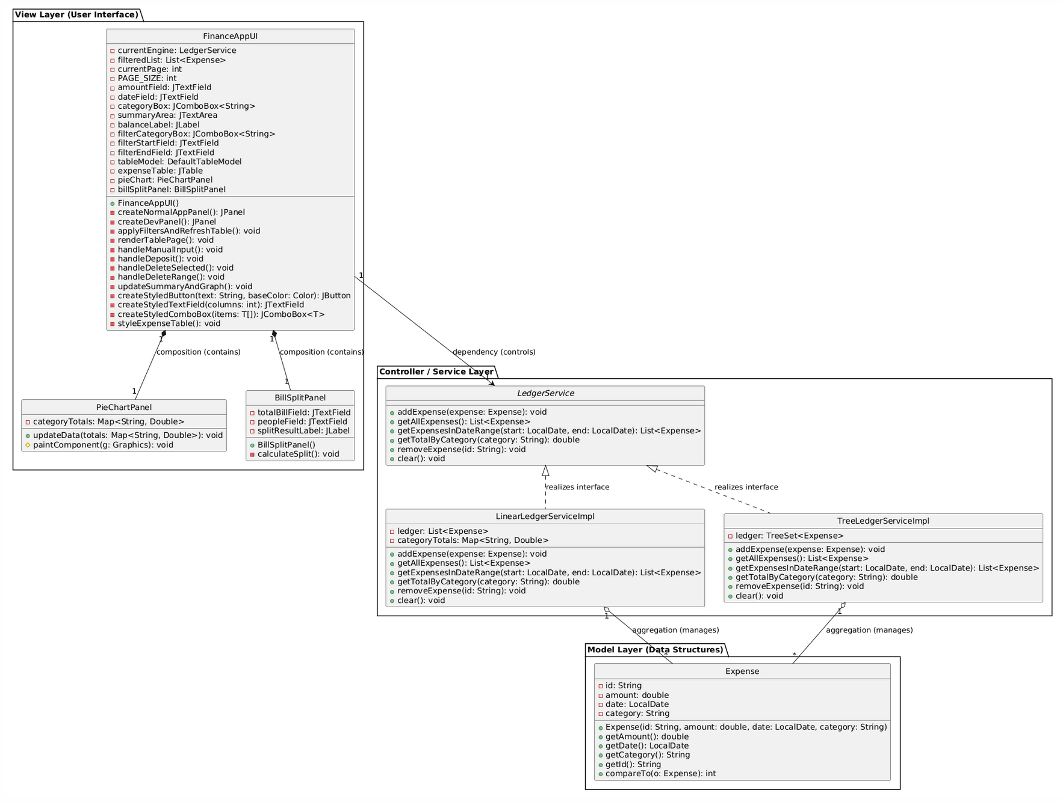

Documentation
Screenshots below provide a quick preview of the application, visual appearance, and coding structure of the Finance Tracker App Final Project.
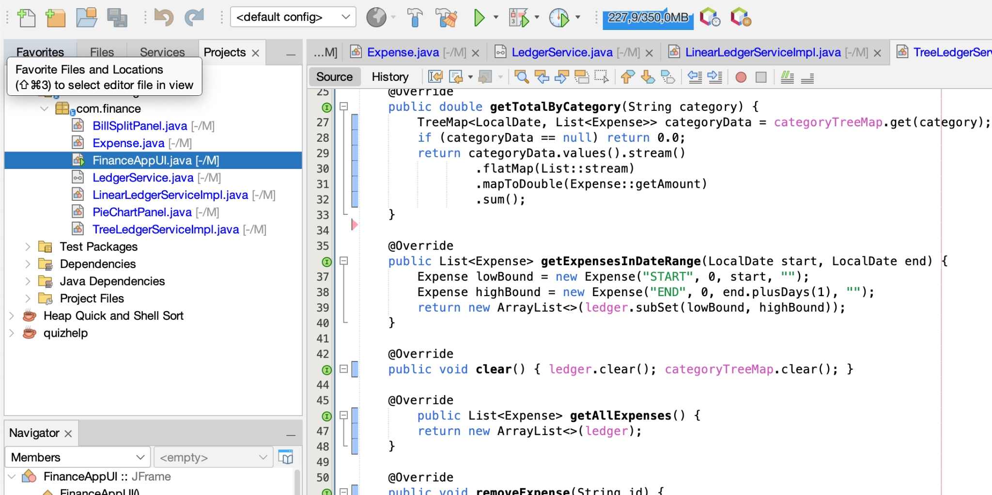
(Code Structure and Hierarchy)
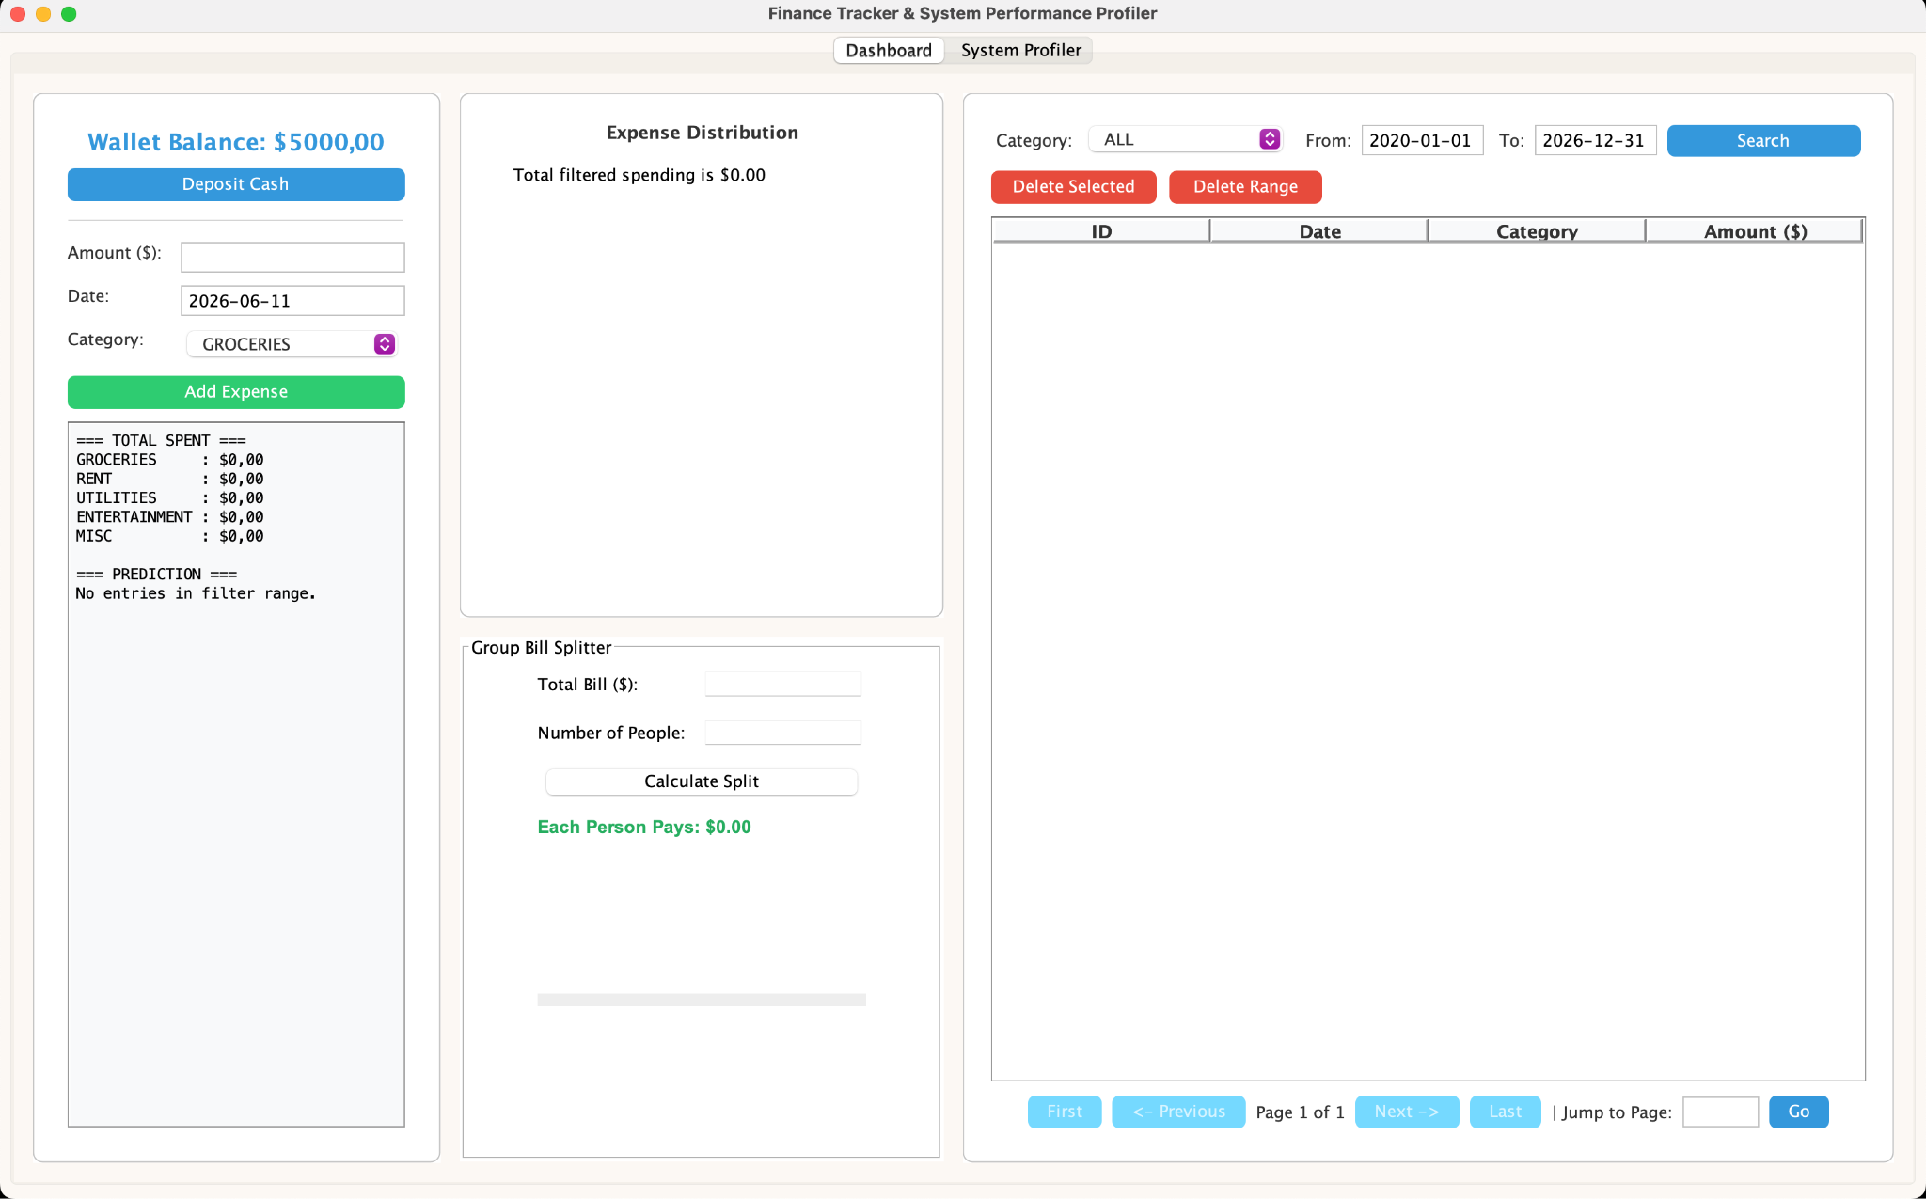
(The entire frontend page)
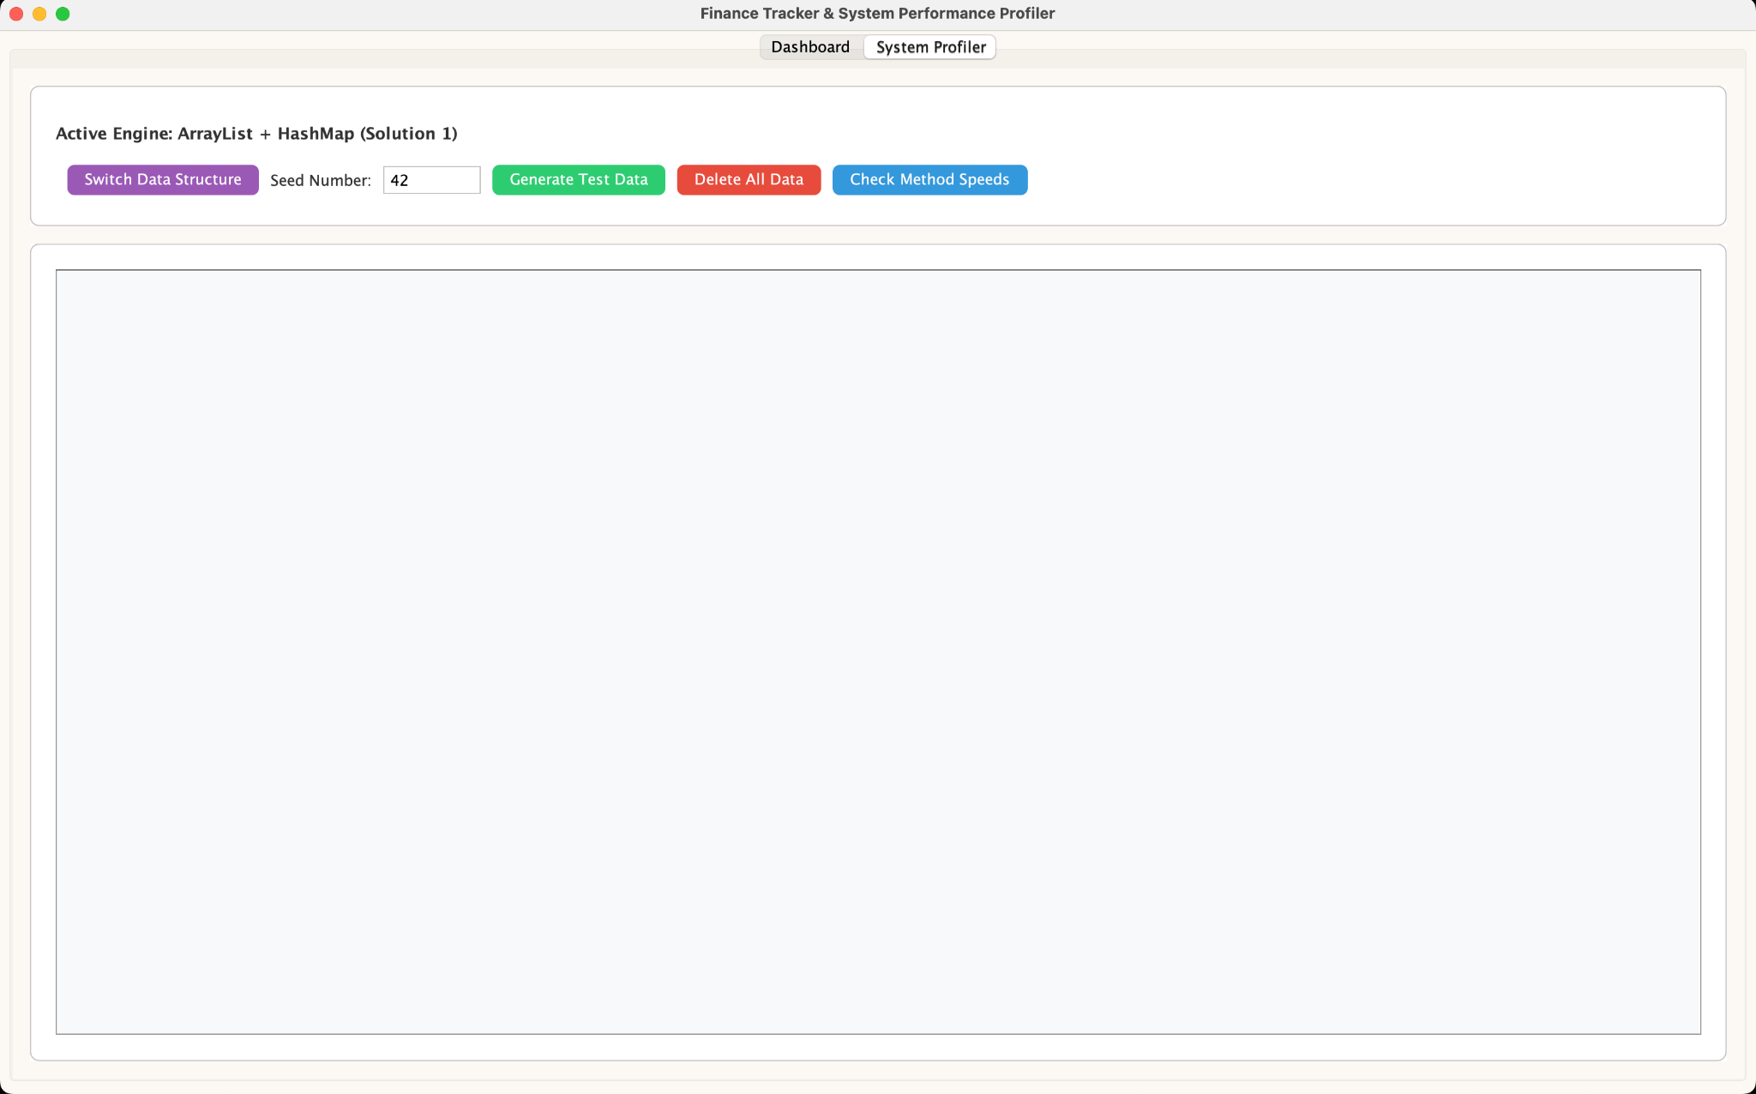

(The system profiler)

REFERENCES

Baeldung. (2024). A guide to TreeSet in Java. https://www.baeldung.com/java-tree-set
Einav, L., & Levin, J. (2014). The Data Revolution and Economic Analysis. Innovation Policy and the Economy, 14, 1–24. https://doi.org/10.1086/674019
GeeksforGeeks. (2023). HashMap class in Java with examples. https://www.geeksforgeeks.org/java/hashmap-class-methods-java-examples-set-1-put-get-isempty-size/
Goodhue, D. L., Wybo, M. D., & Kirsch, L. J. (1992). The Impact of Data Integration on the Costs and Benefits of Information Systems. MIS Quarterly, 16(3), 293–311. JSTOR. https://doi.org/10.2307/249530
Hope AI. (2021). Linear regression from scratch in Java. Analytics Vidhya. Medium. https://medium.com/analytics-vidhya/linear-regression-from-scratch-in-java-dc7aead2ba04
Jarmin, R. S. (2019). Evolving Measurement for an Evolving Economy: Thoughts on 21st Century US Economic Statistics. The Journal of Economic Perspectives, 33(1), 165–184. https://www.jstor.org/stable/26566982
Justus2220, & WJS. (2020). Trying to draw a pie chart with AWT in Java [Online forum post]. Stack Overflow. https://stackoverflow.com/questions/62374617/trying-to-draw-a-pie-chart-with-awt-in-java
KENNEY, M., & ZYSMAN, J. (2016). The rise of the platform economy. Issues in Science and Technology, 32(3), 61–69. http://www.jstor.org/stable/24727063
Mantha, R. W. (1987). Data Flow and Data Structure Modeling for Database Requirements Determination: A Comparative Study. MIS Quarterly, 11(4), 531. https://doi.org/10.2307/248983
McNeill, K. (2015). Repository Options for Research Data. Purdue University Press EBooks, 15–30. https://doi.org/10.2307/j.ctt1wf4drg.7
Mian, A., & Rosenthal, H. (2016). Introduction: Big Data in Political Economy. RSF: The Russell Sage Foundation Journal of the Social Sciences, 2(7), 1. https://doi.org/10.7758/rsf.2016.2.7.01
O’Halloran, S., Maskey, S., McAllister, G., Park, D. K., & Chen, K. (2016). Data Science and Political Economy: Application to Financial Regulatory Structure. RSF: The Russell Sage Foundation Journal of the Social Sciences, 2(7), 87–87. https://doi.org/10.7758/rsf.2016.2.7.06
Scassa, T. (2018). Information Law in the Platform Economy: University of Ottawa Press EBooks, 149–194. https://doi.org/10.2307/j.ctv5vdczv.9
Wang, B., & Li, X. (2017). Big Data, Platform Economy and Market Competition: a Preliminary Construction of Plan-Oriented Market Economy System in the Information Era. World Review of Political Economy, 8(2), 138. https://doi.org/10.13169/worlrevipoliecon.8.2.0138

APPENDIX

Program Manual

- Download the XIP folder from the Finance Tracker project from the Git Repository.
- Extract all the files from the ZIP folder to designated workspace directory.
- Ensure your workspace has the JDK 8 or higher installed.
- Open your preferred IDE and import the extracted folder.
- Navigate the source code by opening the following directories to access the main user interface:
src > com > finance > FinanceAppUI.java
- Run FinanceAppUI.java to run the application.
- Upon opening, you should be at the dashboard. Add expenses to try it out!
- To add randomized data, you go to the System Profilers tab.

Git Repository Link
https://github.com/shakira7/DSOOP-finance-tracker

Presentation Link
https://docs.google.com/presentation/d/1IoQuTD5VD3N_tXzesrtXvpMwc9l0lH25m7ucK8i6ecg/edit?usp=sharing

